Little about S3

S3 is a storage service

S3 bucket name is unique

There are flat files

S3 bucket/upload object

S3 bucket/folder/upload object

We can store bulk data

S3 is AWS cloud service

Here the folder can be uploaded, downloaded and delete

After creating all these permission policies below, we need to login as user and check these

To create s3 bucket

Click on s3 then create bucket

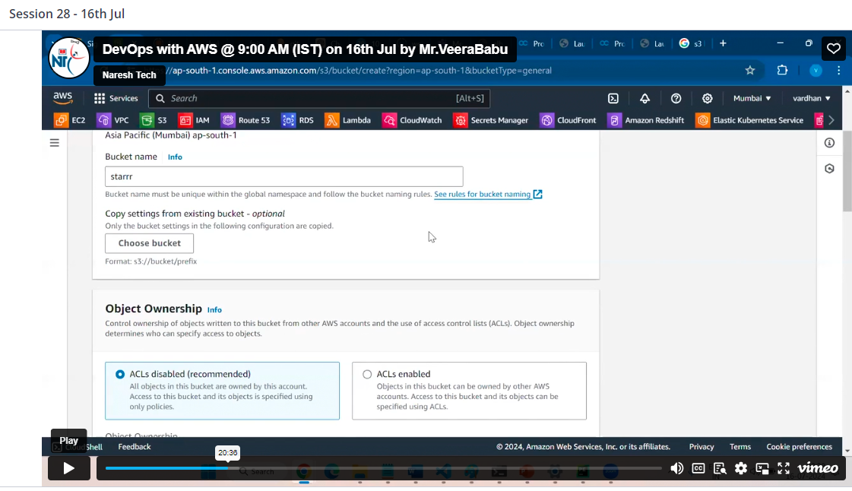

Click on create

Then select on bucket, which created by you

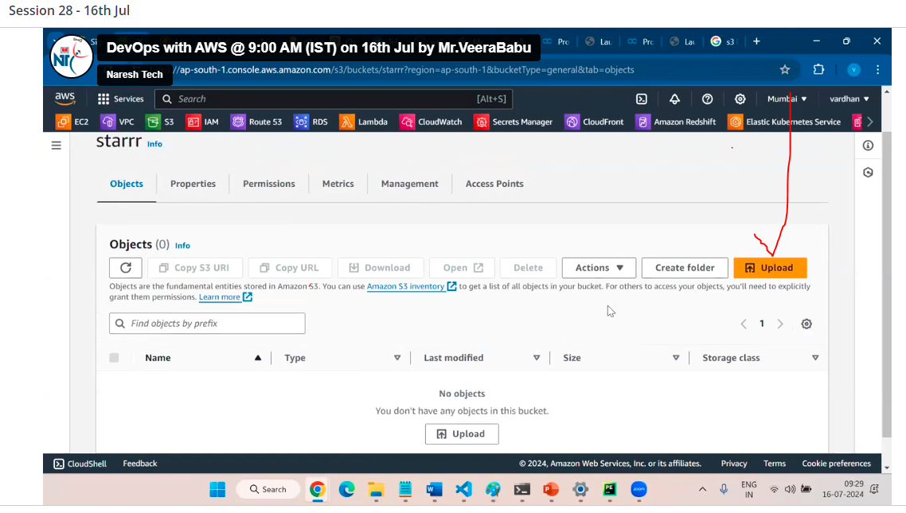

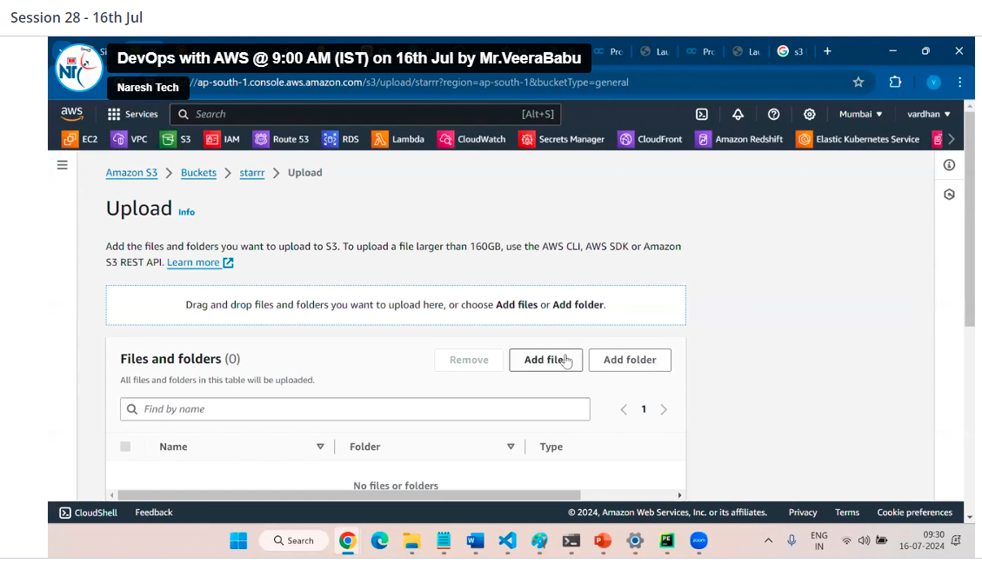

Attach file from local pc and at bottom click on upload

In IAM we have 3 policies

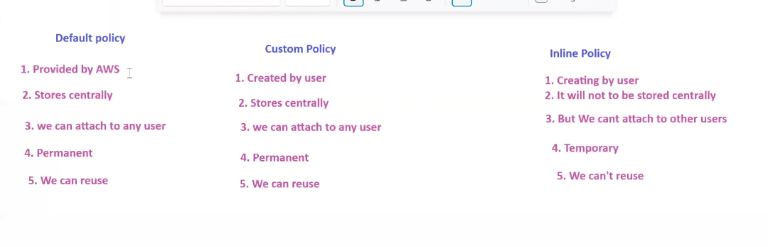

To create custom policy

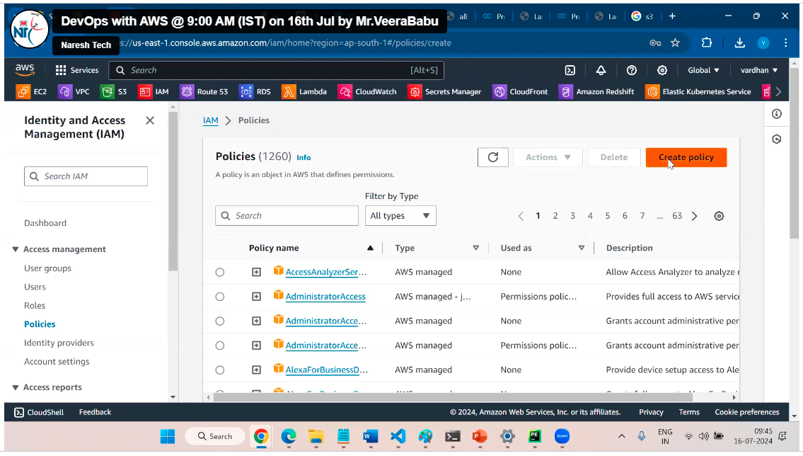

Select your service example S3 and select specific service

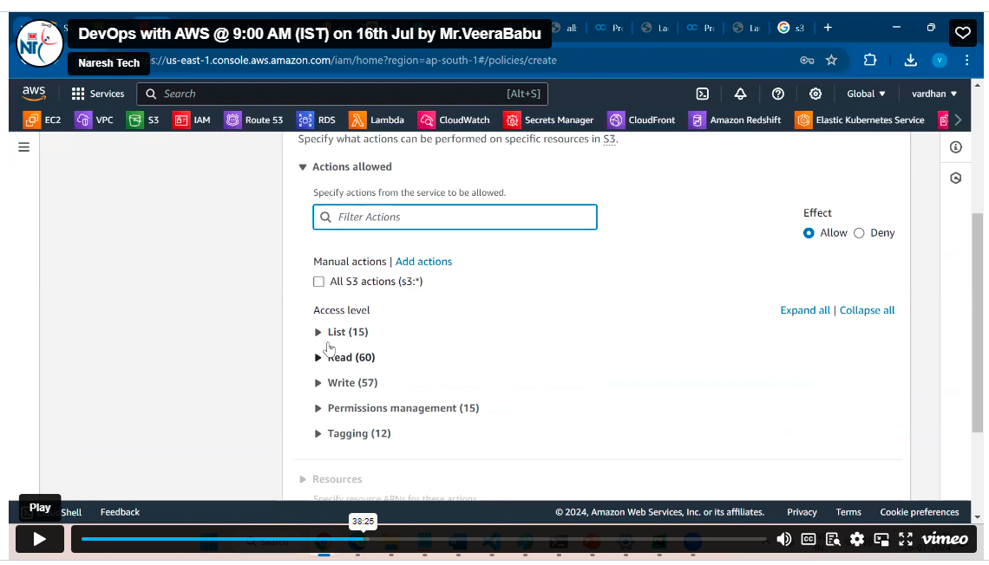

Then click on next(in this case list I have selecte list of all bucket,but I have select only one bucket then see)

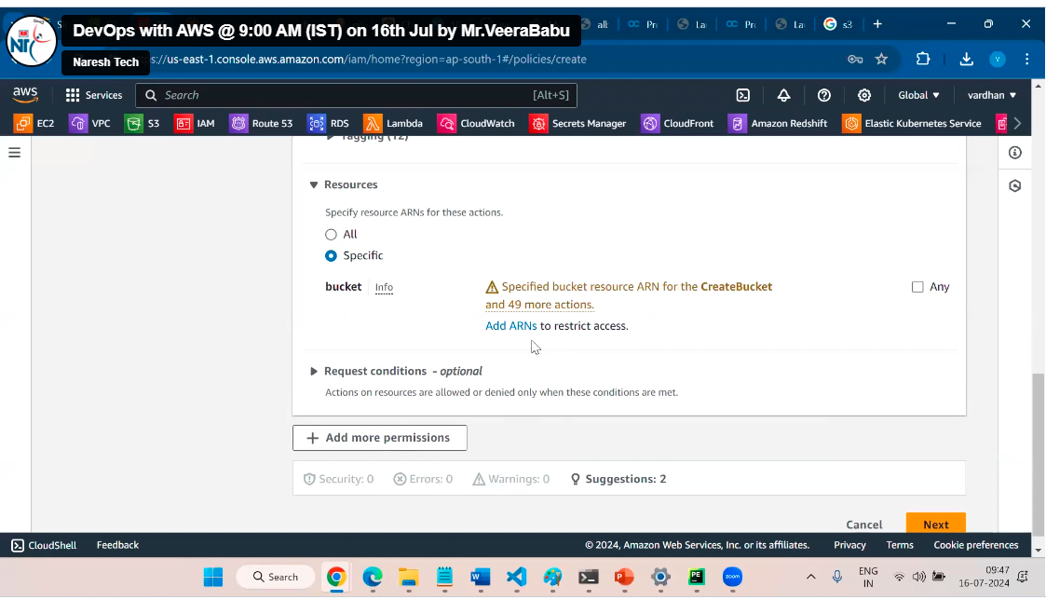

Need to click on Add ARNS and need to add

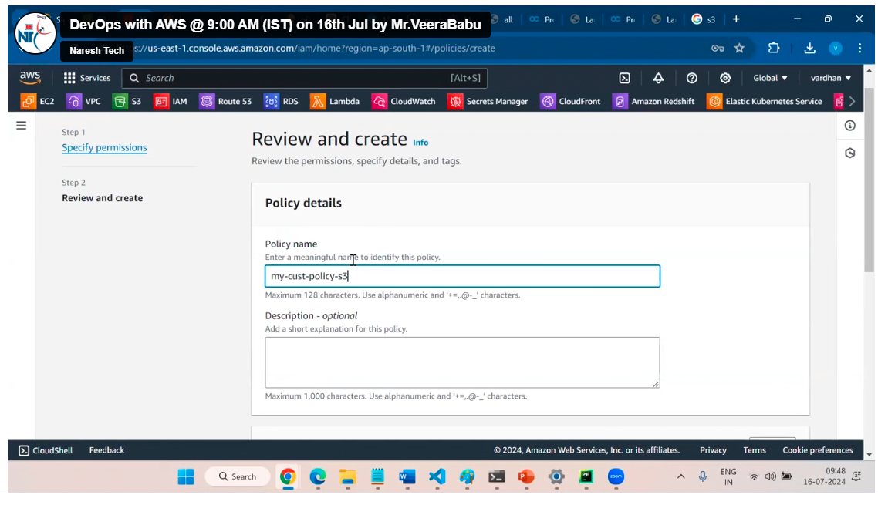

Click on create policy

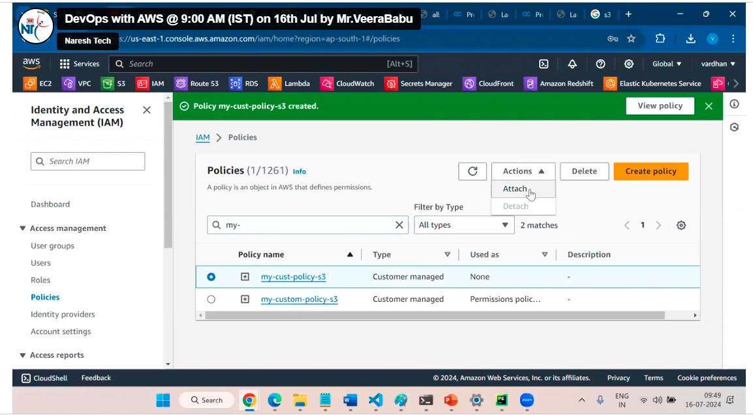

Or

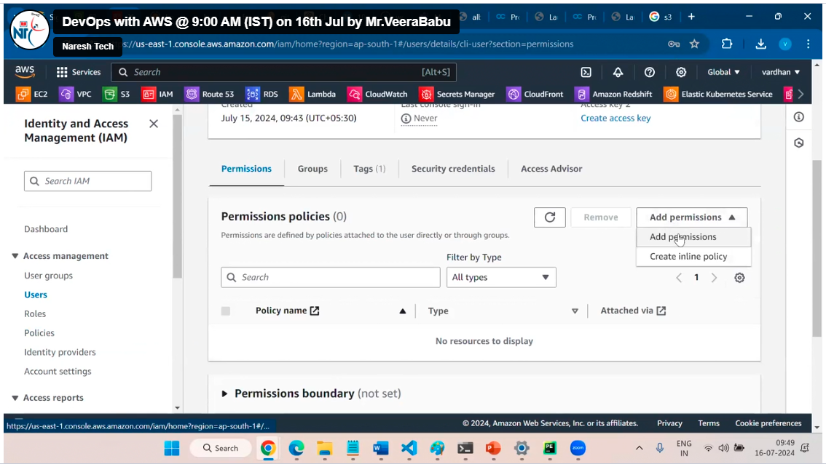

3. Now inline policy

This policy works for this user only the other user cannot use this policy

